

2020 – 12 ATAR Psychology

Task One - Topic Test

5%

Biological Influences and

Bases of Behaviour

Name:

Time: 45 minutes

Score: /46

The diagram below shows the structure of a motor neuron.

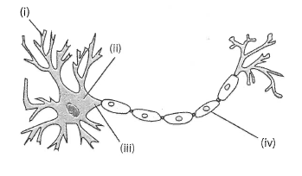

Structure of a motor neuron

1. Describe the purpose of the structure labelled at (i) in the diagram. (1 mark)

|  |
| --- |
|  |
|  |

1. Identify the division of the nervous system in which a motor neuron would be found.

(1 mark)

|  |
| --- |
|  |
|  |

1. Name TWO neurotransmitters that are secreted in the brain. (2 marks)

|  |
| --- |
|  |
|  |
|  |

1. Briefly describe how neurotransmitters are transferred from one neuron to another. You may use an annotated diagram to answer this question. (4 marks)

|  |
| --- |
|  |
|  |
|  |
|  |
|  |

1. Referring to the diagram below, name parts A and B, and briefly explain how they work together to enable a person to respond to a bicycle bell being sounded while they are walking in the middle of a pathway. (5 marks)

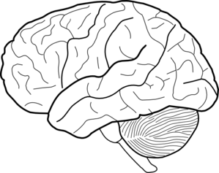

**A**

**B**

|  |
| --- |
|  |
|  |
|  |
|  |
|  |
|  |
|  |
|  |
|  |
|  |
|  |
|  |
|  |

1. 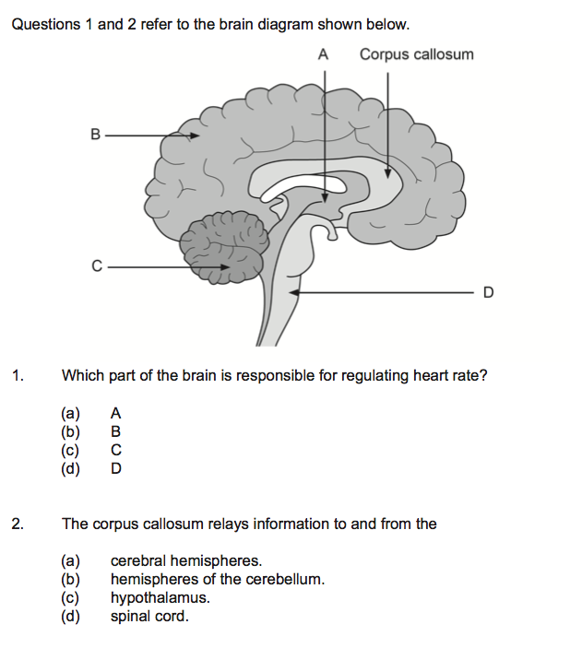Refer to the following diagram to answer the following questions.
2. Describe the structure of the corpus callosum and state its function. (2 marks)

|  |
| --- |
|  |
|  |

1. Name the area of the brainstem labelled “D”. State two functions of D. (3 marks)

|  |
| --- |
|  |
|  |
|  |

1. Name the structure that would be found at “A”. (1 mark)

|  |
| --- |
|  |

1. Use an arrow to indicate where the frontal lobe exists. (1 mark)
2. State two functions of the frontal lobe of the brain. (2 marks)

|  |
| --- |
|  |
|  |
|  |
|  |

1. Refer to the following diagram to answer the following questions. The diagram below shows a section of spinal cord.

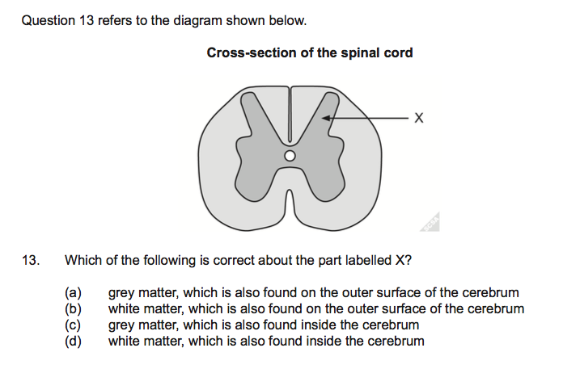

1. Identify the structural material that “X” is pointing to. (1 mark)

|  |
| --- |
|  |

1. Name the main part of the brain where “X” would be found. (1 mark)

|  |
| --- |
|  |

1. State two functions of the spinal cord. (2 marks)

|  |
| --- |
|  |
|  |
|  |
|  |

1. The ‘flight or fight’ response happens when people are confronted with something that could potentially be dangerous.
2. Give one real-life example of a situation where the flight or fight response would occur. (1 mark)

|  |
| --- |
|  |

1. Name one neurotransmitter responsible for this response. (1 mark)

|  |
| --- |
|  |

1. Provide two examples of changes to the way the human body functions as a response to fight or flight. (2 marks)

|  |
| --- |
|  |
|  |
|  |
|  |
|  |

a) If the occipital lobe of the brain was damaged, explain the possible effects a person may experience. (2 marks)

|  |
| --- |
|  |
|  |
|  |
|  |

b) If Wernicke’s area is damaged, explain the possible effects a person may experience.

(2 marks)

|  |
| --- |
|  |
|  |
|  |
|  |

1. Using your knowledge and understanding of genetics, describe three examples of the effects of genetic factors on behaviour. (3 marks)

|  |
| --- |
|  |
|  |
|  |
|  |
|  |
|  |

1. Complete this table on psychoactive drugs: (9 marks)

|  |  |  |  |
| --- | --- | --- | --- |
| **Class of drug** | **One (1) physiological effect** | **One (1) psychological effect** | **Example of a drug in this class** |
| **Depressant** |  |  |  |
| **Stimulant** |  |  |  |
| **Hallucinogen** |  |  |  |

**END OF TEST**